Topic number:

ABSTRACT TITLE

[Presenting author] ⁽¹⁾, [Author # 2] ⁽²⁾, … , [Contacting author] ^{(n), (*)}

⁽¹⁾ [Institution of presenting author]
⁽²⁾ [Institution]
…
^{(n)} [Institution of contacting author]
[E.mail of contacting author]

Extended abstracts should be received by LOC before March 1st 2008, typewritten on A4 format paper, maximum two pages for contributed papers and maximum four pages for invited papers.
Abstract should start with the title, in Times New Roman 14 pts, followed by the name of the author(s) and Institution(s). In the case of several co-authors, the name of the person presenting the contribution should be underlined and that of the contacting author should be indicated with an asterisk. The institution and postal addresses of all authors must be provided together with the electronic mail of the contacting author. The abstract may include line drawing or diagrams but not images or photos.

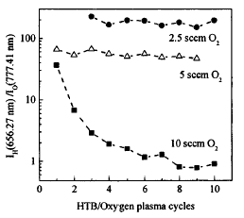

Fig. 1 Captions should be Times New Roman 10 pts. Figures can also be embedded in the text. Text and labels in the figure should be readable.

Note: the printed page format is A4 without colour. Please follow the format of this template: 2 cm margins on each edge plus 1 cm margin for binding the book. The size of the character of the main text should be Times New Roman 11 pts. Line Spacing should be 1.2.

Reference
[1] S. Taylor and P. Pix, 1992 J. Physl. D: Applied Physics 10 1237
[2] G. Owen 1982 Theoretical Approach to Quantum Information (San Diego, CA: Wilak)
[3] Initials and Name, date published, title of journal or book, volume number, editors (if any) and, for books, town of publication and publisher (in parentheses), and finally the page numbers. See Examples above.

